**Exercise 1: Basic Text Formatting**

**Objectives:** Practice using basic text formatting tags including <strong>, <em>, <i>, <b>, <u>, and <s>.

**Requirements:**

* Create an HTML document with a proper structure
* Include at least two paragraphs
* Use each of the required tags at least once
* Create a proper title for the document

Result screenshot

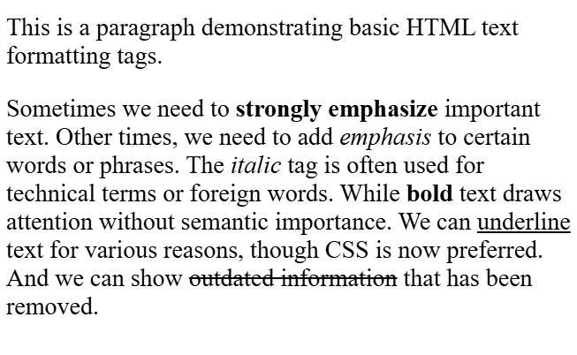

This is a paragraph demonstrating basic HTML text formatting tags.

Sometimes we need to strongly emphasize important text. Other times, we need to add emphasis to certain words or phrases. The italic tag is often used for technical terms or foreign words. While bold text draws attention without semantic importance. We can underline text for various reasons, though CSS is now preferred. And we can show outdated information that has been removed.